Initial Requirements

User Group

The players can either play on a mobile Android device or Windows 10. The project is designed for a single-player experience for people at least 16 years old (due to the complex mature matter covered - human trafficking). The game contains a social aspect in the way of online high scores which grant the user the ability to compare his scores to his friends.

Use Case Diagram

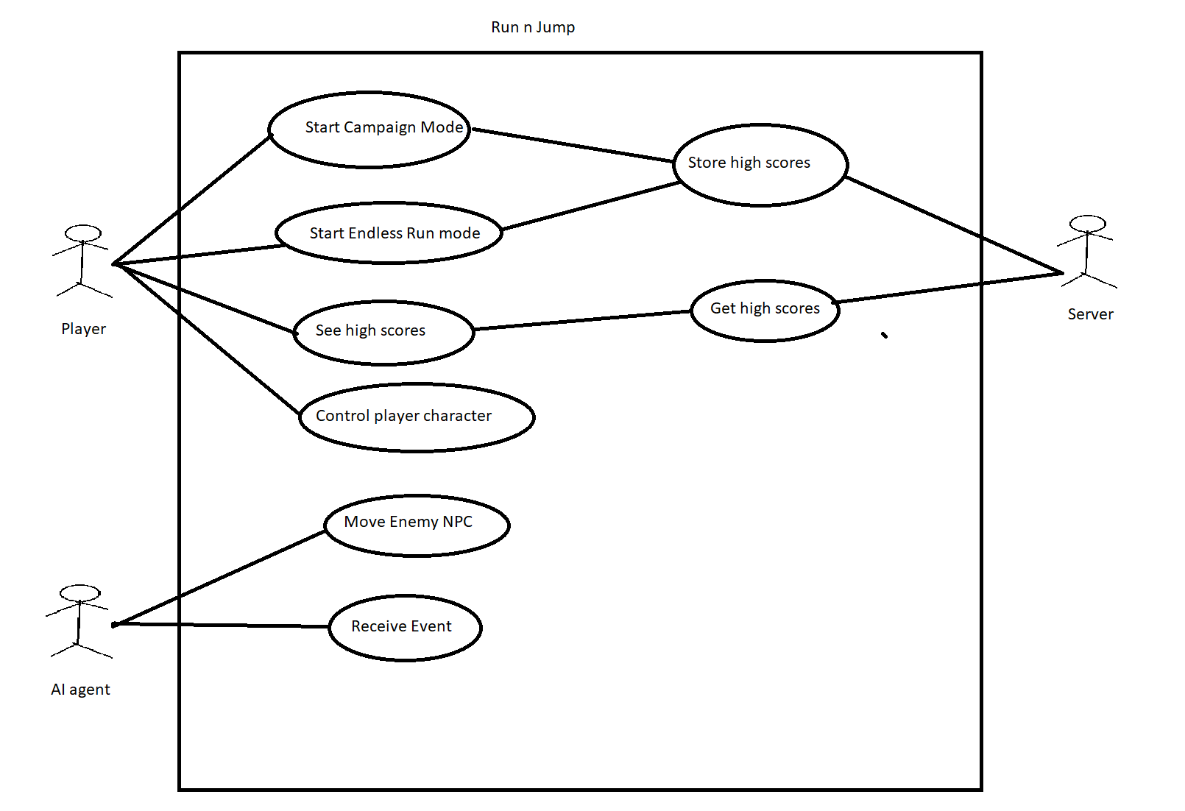

Use Cases

* Name: Start Campaign Mode
* Summary: The player navigates the menu,chooses a level and starts playing it.
* Actors: The Player
* Preconditions: The player has installed the game.
* Sequence:
  + 1. The player starts the game.
  + 2. The player clicks ‘Start’ option
  + 3. The player chooses the level.
* Exceptions:
  + 3. The level the player chose has not been unlocked, a pop up appears telling the player he needs to complete the previous level first.
* Post conditions:
  + The player can now play the level he had chosen.
* Priority: High
* ID: FR1
* Name: See high scores
* Summary: The player navigates the menu and can see the his own highest score in Endless run mode or a campaign level.
* Actors: The Player, Sever
* Preconditions: The player is in game at the main menu.
* Sequence:
  + 1. The player starts the game.
  + 2. The player clicks ‘High-Scores’ option
  + 3. The server sends the high scores to the player.
  + 4. The player clicks ‘Endless Run’ or one of the level high scores..
  + 5. The player clicks on the ‘show my position’ button.
* Exceptions:
  + 3. The server is offline so it cannot send the player the data. A pop up will appear telling the user the date the high scores were last updated and that only his own scores are up-to-date.
  + 3. The player has no access to the internet, a pop up will appear informing the user data cannot be retrieved from the server until an internet connection is established.
  + 5. The player hasn’t completed a level or played the endless run mode so there will not be a highest score for the player. The button will be grayed out, upon clicking the player will be informed there is no player highest score.
* Post conditions:
  + The player can now see his own highest score achieved on the level/mode played.
* Priority: Low
* ID: FR2
* Name: Start Endless Run Mode
* Summary: The player clicks the game mode endless mode in the menu.
* Actors: The Player
* Preconditions: The player has installed the game.
* Sequence:
  + 1. The player starts the game.
  + 2. The player clicks ‘Endless Run’ option
* Exceptions:
  + None
* Post conditions:
  + The player can now play endless run.
* Priority: Medium
* ID: FR3
* Name: Control Player Character
* Summary: The player can run, jump, and interact with certain game elements such as power-ups and enemies.
* Actors: The Player, AI agent
* Preconditions: The game has been started after either choosing a level or endless mode.
* Sequence:
  + 1. The player uses the joystick(android) or arrow keys to move the player character towards the right of the screen.
  + 2. The player sees an obstacle to which he uses the jump key to avoid.
  + 3. The player sees a power-up. He interacts with I and acquires a power-up.
  + 4. The player encounters an enemy agent, he kills it by jumping on it.
* Exceptions:
  + 2. The player hits the obstacle and a game over screen appears with an option to play again.
  + 3. The player fails the mini-game and doesn’t acquire the power up.
  + 4. The player fails to jump on it and instead touches it from the side causing the player to have a game over screen.
* Postconditions: The player can complete the level.
* Priority: High
* ID: FR4
* Name: Move Enemy NPC
* Summary: The AI agent moves around.
* Actors: AI Agent, Player
* Preconditions: The game has started.
* Sequence:
  + 1. The player approaches close enough for the AI agent to turn on its AI. (outside player vision)
  + 2. AI agent determines which NPC it is for.
  + 3. The AI agent moves accordingly.
* Exceptions:
  + 1. The player never moves close enough to the AI, so the NPC never moves.
  + 3. The AI agent determined is a non-moving type, so the NPC doesn’t move.
* Post conditions:
  + The AI agent causes the enemy NPC to move appropriately..
* Priority: High
* ID: FR5
* Name: Receive Event Die
* Summary: The enemy NPC has been killed by the player.
* Actors: AI agent, Player
* Preconditions: The playeris in the vicinity.
* Sequence:
  + 1. The player jumps on top of the NPC or uses a power up to damage the enemy.
  + 2. The AI agent’s sprite disappears.
  + 3. The player’s score is updated.
* Exceptions:
  + 1. The AI agent doesn’t die - the damage done was insufficient.
  + 3. The enemy NPC killed was a type which does not give score points.
* Post conditions:
  + The enemy NPC is no more and the player can move on without worrying about it.
* Priority: Low
* ID: FR6
* Name: Receive Event Kill
* Summary: The enemy NPC has killed the player.
* Actors: AI agent, Player
* Preconditions: The player is in the vicinity.
* Sequence:
  + 1. The enemy NPC touches or hits the player character with a bullet.
  + 2. The player sprite disappears.
  + 3. Game over screen appears.
* Exceptions:
  + 1. The AI agent dealt not enough damage to the player. The player loses a health point.
* Post conditions:
  + The player can see his own high scores for this level/game mode at the game over screen.
* Priority: Medium
* ID: FR7
* Name: Store high scores
* Summary: The score is saved and sent to the server.
* Actors: The Player, Server
* Preconditions: The player has completed a level or ended an endless run mode run.
* Sequence:
  + 1. The player reached the ‘game over’ state.
  + 2. The player is asked to input his name.
  + 3. The player’s score is saved.
  + 4. The player’s score is uploaded to the server.
  + 5. The server stores the player’s high score.
* Exceptions:
  + 2. The player inputs a name which is too long or empty string, this causes a pop up telling you to input a correct name.
  + 4. The server being offline, or the device having no internet connection. This results in a pop up informing the player that the high score will be sent to the server as soon as a connection is established.
* Post conditions:
  + The player can now view his high score and compare it to other people’s.
* Priority: Low
* ID: FR8

Non-Functional requirements

The system will be scalable - it will be robust enough so that new features can be periodically added without adverse effects on the game’s performance or maintainability of the code.

It will be functional - the focus is on getting it to work rather than implementing half-baked features which can negatively impact or destroy the experience.

The system will be educational, the player after finishing the game will have an understanding of human-trafficking better than a person who hasn’t went out of his way to find out about human trafficking.

It will be thought-provoking, the intention is to make the user want to Google the topic of the game - human trafficking- as soon as he completed a run of the game.

Constraints

The game will run on Android and Windows 10. The system has to be able to run on older machines with at least 512mb of RAM memory.

The game must be playable on both a touch screen and with keyboard and mouse.